**PICTORIAL VIEW**

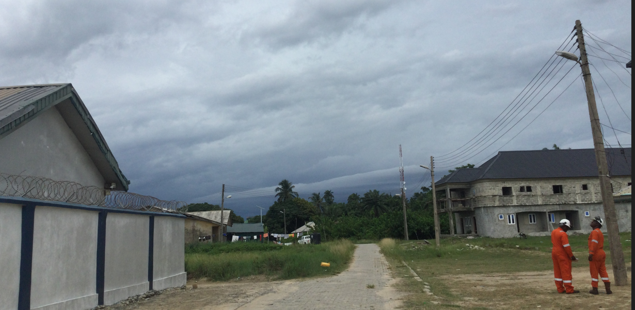

**A**

B

DISTANCE **A to B = 21 Meter**

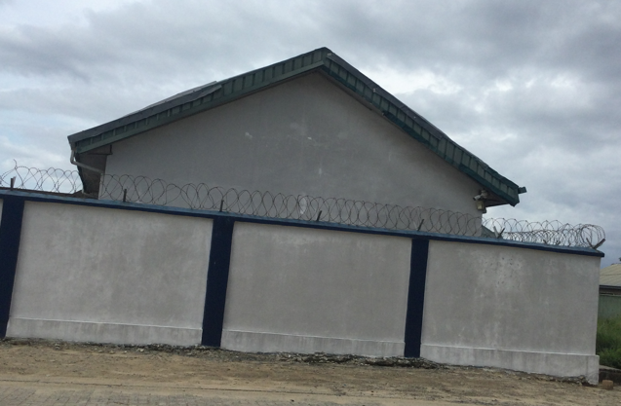

**B**

**C**

DISTANCE **B to C = 5 Meter**

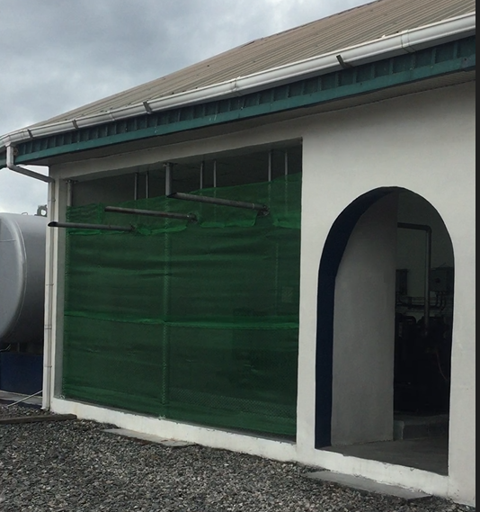

**C**

**D**

DISTANCE **C to D = 10 Meter**

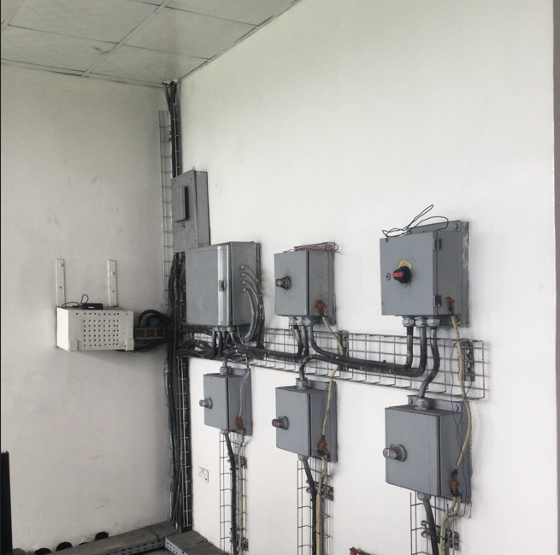

**F**

**E**

**D**

**D**

DISTANCE **D to E = 5 Metre**

DISTANCE **E to F = 4 Metre**

**Proposed length of cable is 50 Meter.**